**19CSE213 Operating Systems Laboratory – Threads Practice**

1. **Write a C program to calculate the factorial value of a number by creating new thread.**

#include <stdio.h>

#include <pthread.h>

void * factorial(void *input) {

int i;

int mul=1;

int *a = (int *)input;

for(i=1 ; i <= *a ; i++){

mul=mul*i;

}

printf("Factorial is: %d \n",mul);

pthread_exit(NULL);

}

int main(void) {

pthread_t tid;

int n;

printf("Enter a Number:");

scanf("%d",&n);

pthread_create(&tid, NULL, factorial, &n);

pthread_join(tid, NULL);

return 0;

}

**Output :**

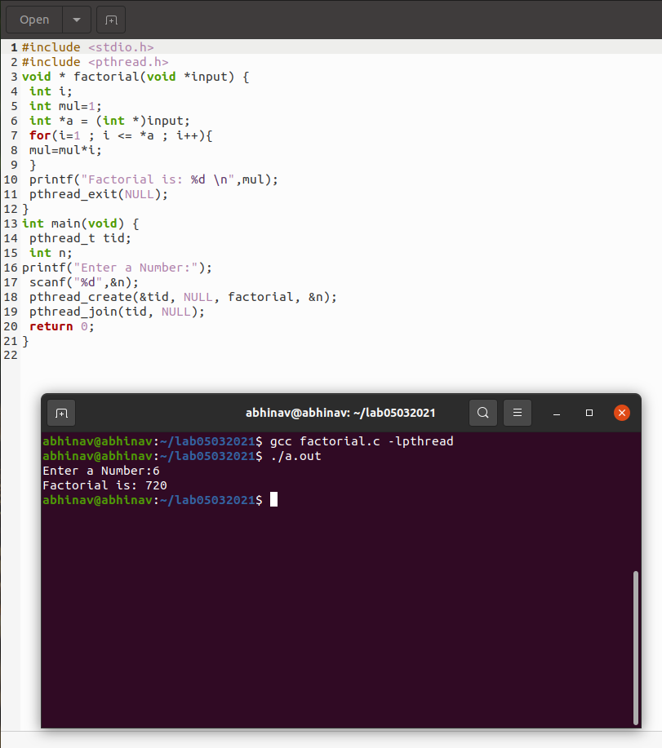

1. **Implement the C program in which main program accepts list of integers. Main program prints the sum of odd numbers from the list of integers. A thread is created and it has to calculate the sum of even numbers from the same list and should be printed by the main thread.**

* **Code :**

#include <pthread.h>

#include <stdio.h>

#include <stdlib.h>

int arr[10];

int even_sum=0;

void read()

{

int i=0;

for(i=0;i<10;i++)

{

printf("Enter number ");

scanf("%d", &arr[i]);

}

}

void printArr()

{

int i=0;

for(i=0; i<10; i++)

{

printf("\narr[%d] : %d",i,arr[i]);

}

}

void print()

{

int sum=0;

int i=0;

for(i=0;i<10;i++)

{

if(arr[i]%2==1)

{

sum+=arr[i];

}

}

printf("odd : %d\n",sum);

}

void *evensum(void *array)

{

int sum=0;

int i=0;

int *a=(int *)array;

for(i=0;i<10;i++)

{

if(arr[i]%2==0)

{

sum+=a[i];

}

}

even_sum=sum;

}

int main()

{

read(arr);

print(arr);

pthread_t tid;

pthread_create(&tid, NULL, evensum, (void*) arr);

pthread_join(tid,NULL);

printf("even : %d\n", even_sum);

return 0;

}

**Snippets :**

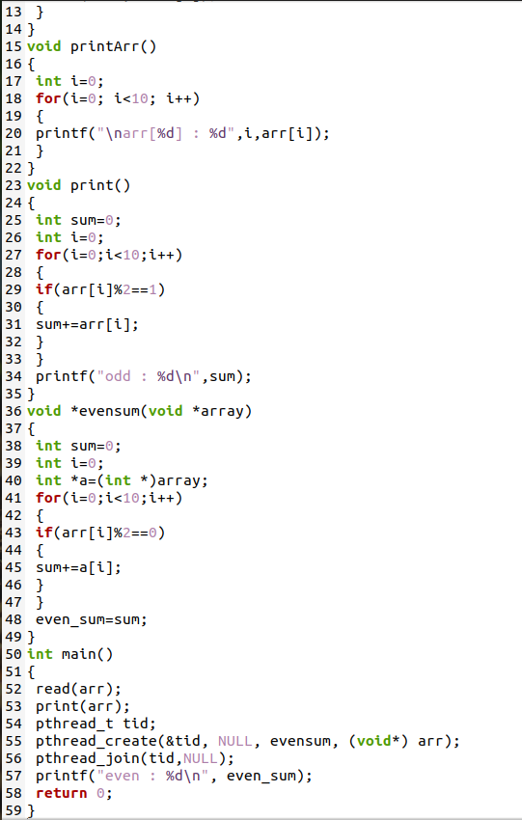

**Output :**

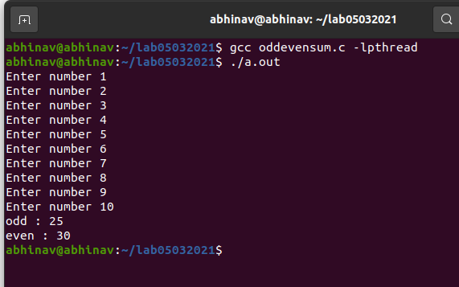

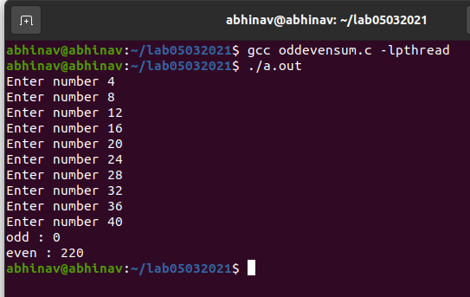

1. **Write a C program to display the student grade sheet. Thread1 should get the details of a student; Thread 2 should get the details of 5 subject marks. Main thread should calculate the grade point and prepare a grade sheet.**

* **Code:**

#include <pthread.h>

#include <stdio.h>

struct thread_data {

char name[100];

char rollno[100];

} thread_data;

int marks[5];

void *myThread(void)

{

printf("Please enter the name : ");

scanf("%s",&thread_data.name);

printf("please enter your roll no: ");

scanf("%s",&thread_data.rollno);

pthread_exit(NULL);

}

void *myThread2(void){

printf("please enter the marks for 5 subjects \n");

for(int i = 0;i < 5;i++){

scanf("%d",&marks[i]);

}

pthread_exit(NULL);

}

int main()

{

pthread_t tid;

pthread_create(&tid, NULL, myThread,NULL);

pthread_join(tid, NULL);

pthread_t tid1;

pthread_create(&tid1, NULL, myThread2,NULL);

pthread_join(tid1, NULL);

printf("The name of the student %s \n",thread_data.name);

printf("The name of the student %s \n",thread_data.rollno);

int sum,points;

sum = 0;

for (int i = 0;i < 5;i++){

points = 0;

if(marks[i] > 90){

sum = sum + 10;

points = points + 10;

}

else if(marks[i] > 80){

sum = sum + 9;

points = points + 9;

}

else if(marks[i] > 70){

sum = sum + 8;

points = points + 8;

}

else if(marks[i] > 60){

sum = sum + 7;

points = points + 7;

}

else if(marks[i] > 50){

sum = sum + 6;

points = points + 6;

}

else if(marks[i] > 40){

sum = sum + 5;

points = points + 5;

}

else if(marks[i] > 30){

sum = sum + 4;

points = points + 4;

}

else{

sum = sum + 3;

points = points + 3;

}

printf("subject %d : %d points \n ",i+1,points);

}

float point = sum/5;

printf("The grade points : %f \n" ,point);

return 0;

}

**Output :**



